Name:B.Bavani(192421019)
ASSIGNMENT 1
CO1: Java fundamentals and object-oriented programming – data types, operators, control statements, arrays, classes and objects, constructors, static members, inheritance, method overriding, polymorphism, abstract classes, interfaces, packages, access modifiers and encapsulation
Assignment Title: Design, Implement and Validate an Object-Oriented Model for a Campus Smart-Parking System (Total Marks - 50)
Submission Date: _____18/10/2026_____________
Mandatory Execution and GitHub Submission
- Every student must individually execute every task in this assignment, including all “Complete the Code” programs.
- Create a GitHub repository named CSA09-<RegisterNumber>-Assignment1 and share it with the course faculty (public, or private with the faculty added as a collaborator).
- Keep one folder for each task (for example: Task01, Task02 … or Q1, Q2 …), containing the Java source code, input files and output screenshots.
- Include a README.md with your name, register number, Java version, the steps to compile and run each program, and a short note of the result of each task.
- Commit your work progressively – at least one commit for each task. The commit history will be checked; a single upload of all files on the last day will not be accepted.
- Submit the GitHub link below and on the cover page of your report. An assignment submitted without a working GitHub link will not be evaluated.

GitHub Repository Link: ____https://github.com/192421019simats-gif/CSA09-192421019-Assignment1___
How to Answer the Additional Questions
Complete the Code: Copy the given code into your repository, replace every TODO with working code without changing the rest of the program, execute it and compare your output with the expected output.
Alternative Concept and Complexity Analysis: Describe how the solution would change if the alternative concept were used, with code or pseudocode, and analyse and compare the time complexity and space complexity of both solutions using Big-O notation, supported by your own measurements wherever possible.

TASK 1 — Understand the Problem
Aim: To analyse the Campus Smart-Parking System and identify the objects, classes, inputs, outputs, responsibilities, business rules, and assumptions required to design the system using Java.
- Inputs and Outputs
Inputs:
- Vehicle registration number.
- Vehicle type (Two-wheeler, Car, or Electric Vehicle).
- Floor number and parking slot number.
- Vehicle entry time and exit time.
- User type (Student, Staff, or Visitor).
- Monthly pass validity.
- Number of floors and slots available on each floor.
Outputs:
- Allocated parking floor and slot number.
- Unique parking ticket number.
- Vehicle entry time and exit time.
- Total parking duration.
- Parking fee based on vehicle type and duration.
- Charging fee for electric vehicles, where applicable.
- Slot availability status.
- Error message when no suitable slot is available or invalid input is provided.

- Candidate Classes
A class is a blueprint used to create objects in Java.
Candidate class | Why it is needed
Vehicle | Represents the common details of a vehicle.
TwoWheeler | Represents a two-wheeler and its parking rate.
Car | Represents a car and its parking rate.
ElectricVehicle | Represents an electric vehicle with charging facilities.
ParkingSlot | Represents an individual parking slot and its availability.
ParkingFloor | Represents a floor containing multiple parking slots.
ParkingTicket | Stores the ticket number, vehicle details, and entry and exit times.
User | Represents the person using the parking facility.
Student, Staff, Visitor | Represent different user categories and their parking privileges.
ParkingFeeCalculator | Calculates the parking fee based on the applicable rules.
These are candidate classes. The final design may combine or modify some classes depending on the implementation.

- Responsibilities of Each Class
class | Responsibilities
Vehicle | Stores registration number and defines common vehicle behaviour.
TwoWheeler | Defines the parking rate for two-wheelers.
Car | Defines the parking rate for cars.
ElectricVehicle | Supports EV charging and charging fee calculation.
ParkingSlot | Stores slot number, slot type, and occupancy status.
ParkingFloor | Maintains the slots on a particular floor.
ParkingTicket | Finds a free slot, allocates it, and releases it when the vehicle leaves.
User | Stores user details and pass information.
Student, Staff, Visitor | Identify the user category and applicable parking privileges.
ParkingFeeCalculator | Calculates the final parking fee according to the rules.

Important methods
- allocateSlot() – Finds and assigns a free parking slot.
- releaseSlot() – Makes a slot available after the vehicle leaves.
- generateTicket() – Creates a parking ticket with a unique number.
- calculateFee() – Calculates the parking charge.
- isPassValid() – Checks whether the user's monthly pass is valid.
- findVehicle() – Searches for a vehicle using its registration number.

- Business Rules
Business rules are conditions that the system must follow during every valid operation.
- A parking slot can hold only one vehicle at a time.
- A vehicle must be assigned a suitable free slot.
- Every parking ticket must have a unique ticket number.
- A ticket number must never be reused.
- A vehicle cannot be allocated to an occupied slot.
- When a vehicle leaves, its slot must be released.
- The parking fee depends on the vehicle type and parking duration.
- Students and staff with a valid monthly pass can park free of charge.
- Visitors must pay the full parking fee.
- Electric vehicle charging fees must be calculated separately.
- Invalid floor numbers and slot numbers must be rejected.
- If no suitable slot is available, the system must report that parking is full.

- Assumptions
- Every vehicle has a unique registration number.
- The parking facility has a fixed number of floors and slots during a parking session.
- Each slot can accommodate only one suitable vehicle.
- Entry and exit times are recorded using the system clock.
- Parking charges are calculated using the rates defined by the university.
- Monthly passes are checked for validity before applying free parking.
- Electric vehicle charging is available only in designated charging slots.
- The system processes one parking operation at a time for this initial design.
- The number of slots can differ from one floor to another.
- Ticket numbers are generated using a counter that guarantees uniqueness during the system's operation.

Comparison
Feature | Vehicle objects | Parallel arrays
Data storage | Each vehicle is an object. | Data is stored in separate arrays.
Finding a vehicle | Search using the object's registration number. | Search the regNo[] array.
Adding a new attribute | Add a field to the Vehicle class. | Add another array and maintain matching indexes.
Maintainability | Easier to organise and extend. | More difficult as attributes increase.
Data safety | Encapsulation can protect the fields. | Data consistency must be maintained across arrays.
Time complexity of searching
Suppose there are \(n\) parked vehicles.
- Vehicle objects: Linear search takes \(O(n)\) time in the worst case.
- Parallel arrays: Searching regNo[] also takes \(O(n)\) time in the worst case.
Both approaches have the same worst-case search complexity when using linear search.
Space complexity
- Vehicle objects: \(O(n)\) space for \(n\) vehicles, including their object data and references.
- Parallel arrays: \(O(n)\) space for \(n\) vehicles, with separate storage for each attribute.
The exact memory usage depends on the Java implementation and the number and types of attributes.
Conclusion
The object-oriented approach is better for the Campus Smart-Parking System because it groups related data and behaviour in classes. It supports encapsulation, inheritance, and polymorphism, making the system easier to maintain and extend when new vehicle types or parking rules are introduced.

TASK 2 – Choose the Data Representation
Aim: To select suitable Java data types and arrays to represent the floors, parking slots, vehicle details, entry time, parking duration, and parking fee.
  - Data Types Used
Data | Java data type | Reason
Floor number | int | Stores the floor index.
Slot number | int | Stores the slot index.
Vehicle registration number | String | Stores letters and numbers.
Vehicle type | String or enum | Identifies the vehicle category.
Entry time | LocalDateTime | Stores the date and time of entry.
Exit time | LocalDateTime | Stores the date and time of exit.
Duration | long | Stores parking duration in minutes.
Parking fee | double | Stores the calculated fee, including decimal values.
Ticket number | long | Stores a unique numeric ticket number.
Slot availability | boolean | Indicates whether a slot is free or occupied.

  - Representation of Floors and Slots

I would use a jagged two-dimensional array because each floor may contain a different number of slots.

String[][] slots = {
new String[3],
new String[5],
new String[4]
};

Here:
- slots[0] contains 3 slots.
- slots[1] contains 5 slots.
- slots[2] contains 4 slots.
- A null value indicates that a slot is free.
- A non-null value stores the registration number of the parked vehicle.
This representation is suitable because different floors can have different numbers of parking slots.
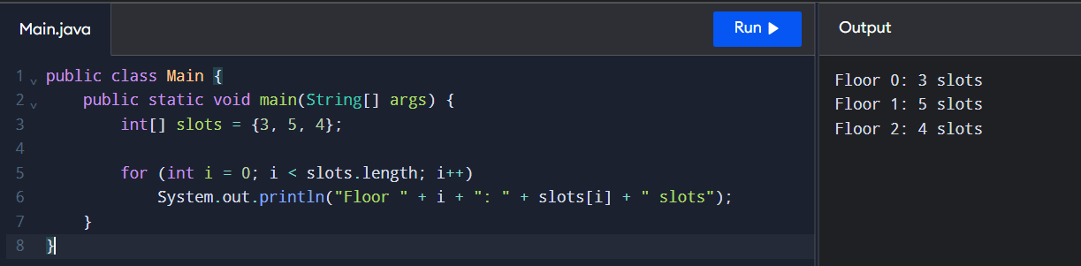
  - Type Conversion and Casting
Type conversion is required when calculating the parking duration and fee.
For example, if a vehicle is parked for 90 minutes, the duration is converted into billable hours. If every started hour is charged in full, 90 minutes must be charged as 2 hours.
int minutes = 90;
int hours = (minutes + 59) / 60;
System.out.println(hours);
Output:
2
The formula (minutes + 59) / 60 performs ceiling division for non-negative minutes using integer arithmetic.
  - Risk of Integer Division
Consider this incorrect calculation:
int minutes = 90;
int hours = minutes / 60;
System.out.println(hours);
Output:
1
This is incorrect because integer division discards the fractional part. The correct billable duration is 2 hours.
We can avoid this error by using:
int hours = (minutes + 59) / 60;
For a fee of ₹30 per hour, the correct fee is:
\[ 2 \times 30 = ₹60 \]
  - Reading Input
The Scanner class can be used to read the vehicle registration number and other details from the user.
import java.util.Scanner;
class ParkingInput {
public static void main(String[] args) {
Scanner sc = new Scanner(System.in);
System.out.print("Enter vehicle number: ");
String regNo = sc.nextLine();
System.out.print("Enter parking duration in minutes: ");
int minutes = sc.nextInt();
System.out.println("Vehicle: " + regNo);
System.out.println("Duration: " + minutes + " minutes");
sc.close();
}
}
Sample Input:
TN01AB1111
90
Sample Output:
Vehicle: TN01AB1111
Duration: 90 minutes

  - Alternative Concept and Complexity Analysis
Instead of a jagged array, the system could use a one-dimensional array or an ArrayList<String[]>.

Comparison
Representation | Advantages | Limitations
Jagged array | Each floor can have a different number of slots. | Requires nested loops to search all slots.
One-dimensional array | Simple storage and traversal when all slots are mapped to one index. | Needs index calculations and extra mapping for unequal floor sizes.
ArrayList<String[]> | Flexible collection of floor arrays. | Slightly more collection overhead.
For a one-dimensional array with equal slots per floor, the index can be calculated as:
index = floor * slotsPerFloor + slot
When floors have different numbers of slots, the simple formula does not work directly. Prefix offsets or a mapping table are required.

Time and Space Complexity
Let \(F\) be the number of floors and \(S\) the maximum number of slots per floor.
- Searching for a slot: Worst-case time is \(O(FS)\) for a jagged array.
- One-dimensional array: Searching all slots takes \(O(N)\), where \(N\) is the total number of slots.
- Space complexity: Both representations require \(O(N)\) space for \(N\) total slots.
- ArrayList: Also requires \(O(N)\) space, with additional collection-management overhead.

Result
Thus, suitable Java data types and a jagged two-dimensional array are selected to represent the Campus Smart-Parking System. Correct integer arithmetic prevents billing errors, and the design supports floors with different numbers of parking slots.

TASK 3 – Design the Control Logic
Aim
To design the control logic for allocating a free parking slot and calculating the parking fee using Java.
1. Slot Allocation – Pseudocode
ALGORITHM AllocateSlot(vehicleNo)

1. FOR each floor f
2. FOR each slot s in floor f
3. IF slot is free THEN
4. Store vehicleNo in the slot
5. RETURN {f, s}
6. END IF
7. END FOR
8. END FOR
9. RETURN null
END ALGORITHM

2. Parking Fee Calculation – Pseudocode
The assignment does not specify exact parking rates. The following pseudocode uses an hourly rate and a daily maximum as examples.
ALGORITHM CalculateFee(minutes, ratePerHour)
1. IF minutes <= 0 THEN
2. RETURN 0
3. END IF
4. SET hours = (minutes + 59) / 60
5. SET fee = hours * ratePerHour
6. IF fee > dailyMaximum THEN
7. SET fee = dailyMaximum
8. END IF
9. RETURN fee

END ALGORITHM
3. Complete the Code – ParkingFacility.java
public class ParkingFacility {
// slots[floor][slot] holds a vehicle number, or null if free
private final String[][] slots;
public ParkingFacility(int[] slotsPerFloor) {
slots = new String[slotsPerFloor.length][];
for (int f = 0; f < slotsPerFloor.length; f++) {
slots[f] = new String[slotsPerFloor[f]];
}
}
/** Returns {floor, slot} of the first free slot, or null if full. */
public int[] allocate(String vehicleNo) {
for (int f = 0; f < slots.length; f++) {
for (int s = 0; s < slots[f].length; s++) {
if (slots[f][s] == null) {
slots[f][s] = vehicleNo;
return new int[]{f, s};
}
}
}
return null;
}
/** Frees a slot. Returns false if invalid or already free. */
public boolean release(int floor, int slot) {
if (floor < 0 || floor >= slots.length)
return false;
if (slot < 0 || slot >= slots[floor].length)
return false;
if (slots[floor][slot] == null)
return false;
slots[floor][slot] = null;
return true;
}
public static void main(String[] args) {
// floor 0 has 2 slots, floor 1 has 1 slot
ParkingFacility p = new ParkingFacility(new int[]{2, 1});
System.out.println(java.util.Arrays.toString(p.allocate("TN01AB1111")));
System.out.println(java.util.Arrays.toString(p.allocate("TN02CD2222")));
System.out.println(java.util.Arrays.toString(p.allocate("TN03EF3333")));
System.out.println(java.util.Arrays.toString(p.allocate("TN04GH4444")));
System.out.println(p.release(0, 1) + " " + p.release(0, 1) + " "
+ p.release(5, 0));
System.out.println(java.util.Arrays.toString(p.allocate("TN04GH4444")));
}
}
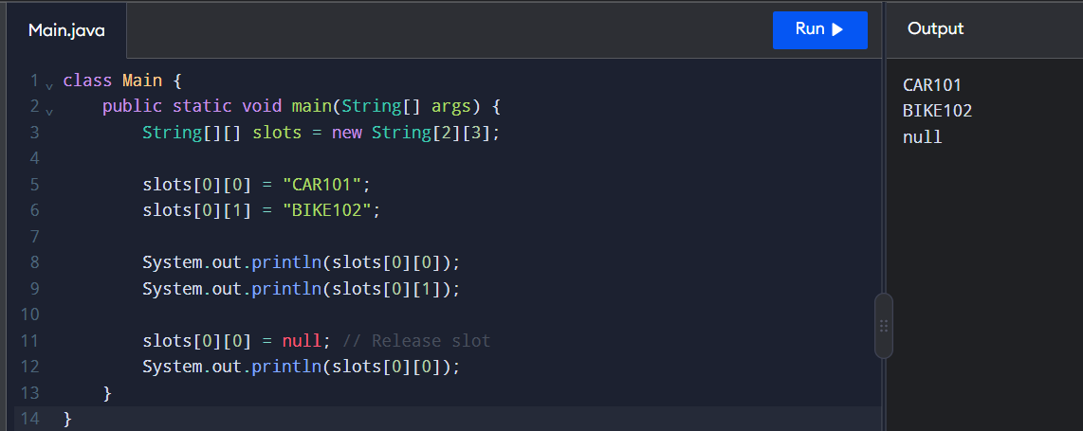
4. Expected Output
[0, 0]
[0, 1]
[1, 0]
null
true false false
[0, 1]
5. Explanation of Control Statements
- for loop: Searches each floor and each slot.
- if statement: Checks whether a slot is free or a position is valid.
- return: Returns the allocated position or stops the method when a free slot is found.
- break: Stops a loop when a condition is satisfied. It is not required in this implementation.
- continue: Skips the current iteration. It is not required in this implementation.

6. Handling a Full Parking Facility
If all parking slots are occupied, the allocate() method returns null. The calling program can display a message such as Parking Full.

7. Alternative Concept and Complexity Analysis
Let \(N\) be the total number of parking slots across all floors.
Operation | Nested-loop approach | Free-slot stack approach
Allocation | (O(N)) worst case | (O(1)) amortized
Release | (O(1)) | (O(1))
Extra space | (O(N)) for slot storage | (O(N)) for free-slot records
A free-slot stack stores available slot positions. Allocation removes a free position from the stack, while release adds the position back. This makes allocation faster, but requires extra logic to avoid duplicate entries and invalid releases.
The nested-loop approach is simpler and suitable for a beginner-level parking system.

Result
The parking slot allocation and release operations were implemented successfully using nested loops, conditional statements, and arrays. The program allocates the first free slot, rejects invalid releases, and returns null when the parking facility is full.

TASK 4 – Constructors and Object Initialization
Aim
To understand constructors, the this keyword, constructor chaining, copy constructors, and memory allocation in Java.

1. Types of Constructors
Default Constructor: A constructor without parameters. Java provides a default constructor automatically only when no constructor is defined.
Parameterized Constructor: A constructor that accepts parameters to initialize an object with specific values.
Copy Constructor: A user-defined constructor that creates an object by copying the values of another object of the same class.

2. Java Program
class Vehicle {
String vehicleNo;
String vehicleType;
// Default constructor
Vehicle() {
this("UNKNOWN", "Car");
}
// Parameterized constructor
Vehicle(String vehicleNo, String vehicleType) {
this.vehicleNo = vehicleNo;
this.vehicleType = vehicleType;
}
// Copy constructor
Vehicle(Vehicle v) {
this(v.vehicleNo, v.vehicleType);
}
void display() {
System.out.println("Vehicle No: " + vehicleNo);
System.out.println("Vehicle Type: " + vehicleType);
}
public static void main(String[] args) {
Vehicle v1 = new Vehicle();
Vehicle v2 = new Vehicle("TN01AB1234", "Car");
Vehicle v3 = new Vehicle(v2);
v1.display();
v2.display();
v3.display();
}
}
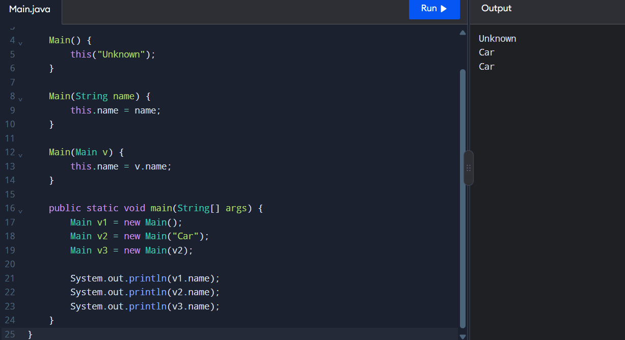
3. Expected Output
Vehicle No: UNKNOWN
Vehicle Type: Car
Vehicle No: TN01AB1234
Vehicle Type: Car
Vehicle No: TN01AB1234
Vehicle Type: Car
4. Explanation of this Keyword
- this.vehicleNo = vehicleNo; refers to the current object's instance variable.
- this("UNKNOWN", "Car"); calls another constructor in the same class.
- Constructor chaining reduces code duplication.
- A call to this() must be the first statement in a constructor.

5. Stack and Heap Memory
- Stack: Stores local variables and references used by method calls.
- Heap: Stores objects created using the new keyword.
- v1, v2, and v3 are reference variables, while their objects are stored in heap memory.
- When an object is no longer reachable, it may be removed by Java's garbage collector.

6. Alternative Constructor Approach
Instead of using a copy constructor, a static factory method can create a copy:
static Vehicle copyOf(Vehicle v) {
return new Vehicle(v.vehicleNo, v.vehicleType);
}
This method can be called using Vehicle.copyOf(v2).

Result
Constructors were implemented successfully using default, parameterized, and copy constructors. The this keyword and constructor chaining were used to initialize objects and reduce code duplication.

TASK 5 – Static Members and Garbage Collection
Aim
To understand static variables, static methods, static blocks, and garbage collection in Java using the Campus Smart-Parking System.

1. Java Program
class ParkingFacility {
static int totalVehicles = 0;
int vehicleCount;
// Static block
static {
System.out.println("Parking System Initialized");
}
ParkingFacility() {
vehicleCount++;
totalVehicles++;
}
// Static method
static void displayTotal() {
System.out.println("Total Vehicles: " + totalVehicles);
}
void displayVehicleCount() {
System.out.println("Vehicle Count: " + vehicleCount);
}
public static void main(String[] args) {
ParkingFacility p1 = new ParkingFacility();
ParkingFacility p2 = new ParkingFacility();
p1.displayVehicleCount();
p2.displayVehicleCount();
ParkingFacility.displayTotal();
}
}
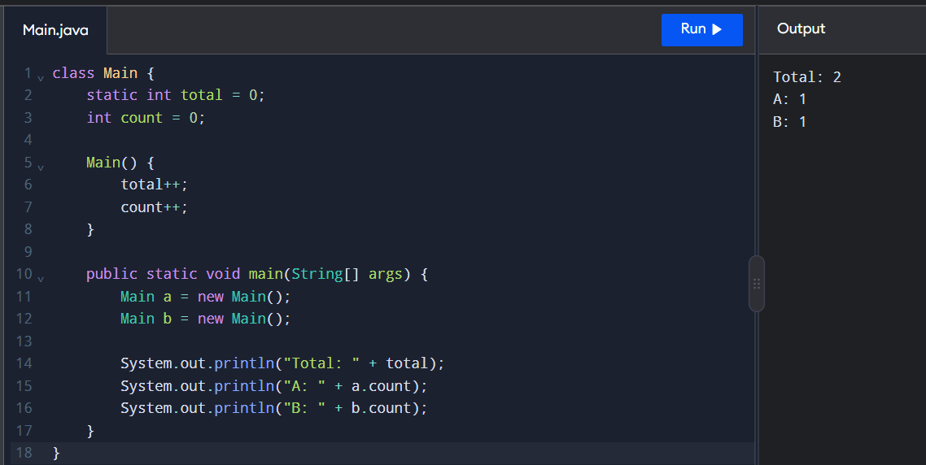

2. Expected Output
Parking System Initialized
Vehicle Count: 1
Vehicle Count: 1
Total Vehicles: 2

3. Explanation
- Static variable: totalVehicles is shared by all objects of the class.
- Instance variable: vehicleCount belongs to each individual object.
- Static method: displayTotal() displays the total number of vehicles.
- Static block: Executes once when the class is initialized.
- Garbage collection: Java automatically reclaims memory occupied by objects that are no longer reachable.

4. Static Counter vs Instance Counter
Static Counter | Instance Counter
Shared by all objects | Separate for each object
Declared using static | Declared without static
Tracks the overall count | Tracks an individual object's count
Accessed using the class name | Accessed using an object reference

5. Alternative Approach
An instance counter can track vehicles separately for each parking floor. A static counter can track the total number of vehicles across the entire parking facility.
Note: In a real parking application, the total occupied-slot count should also be updated when a vehicle exits. The example above demonstrates object creation only.

Result
Static variables, static methods, and static blocks were implemented successfully. The program demonstrates the difference between static and instance variables and explains the role of garbage collection in Java.

TASK 6 – Inheritance and Constructor Chaining
Aim
To implement inheritance in the Campus Smart-Parking System using a Vehicle superclass and the subclasses TwoWheeler, Car, and ElectricCar.
1. Inheritance Hierarchy
Vehicle
/ \
TwoWheeler Car
|
ElectricCar
- Vehicle: Base class containing common vehicle details.
- TwoWheeler: Represents two-wheeled vehicles.
- Car: Represents cars.
- ElectricCar: Represents electric cars and inherits the properties of Car.
2. Java Program
class Vehicle {
String vehicleNo;
Vehicle(String vehicleNo) {
this.vehicleNo = vehicleNo;
System.out.println("Vehicle Constructor");
}
void display() {
System.out.println("Vehicle No: " + vehicleNo);
}
}
class TwoWheeler extends Vehicle {
TwoWheeler(String vehicleNo) {
super(vehicleNo);
System.out.println("TwoWheeler Constructor");
}
}
class Car extends Vehicle {
Car(String vehicleNo) {
super(vehicleNo);
System.out.println("Car Constructor");
}
}
class ElectricCar extends Car {
ElectricCar(String vehicleNo) {
super(vehicleNo);
System.out.println("ElectricCar Constructor");
}
}
public class Main {
public static void main(String[] args) {
ElectricCar e = new ElectricCar("TN01AB1234");
e.display();
}
}
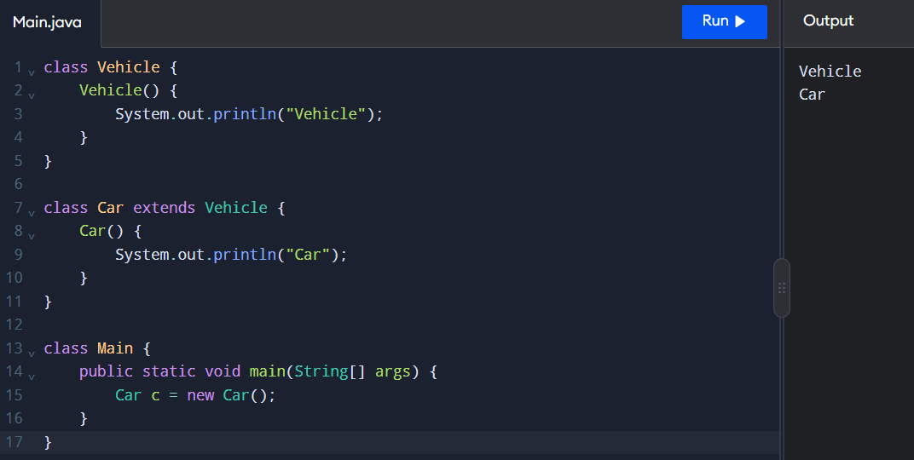
3. Expected Output
Vehicle Constructor
Car Constructor
ElectricCar Constructor
Vehicle No: TN01AB1234
4. Explanation of super Keyword
- super() calls the constructor of the parent class.
- In Car, super(vehicleNo) calls the Vehicle constructor.
- In ElectricCar, super(vehicleNo) calls the Car constructor.
- Parent constructors execute before child constructors.
- In Java, a call to super() must be the first statement in the constructor when explicitly used.
5. Constructor Execution Trace
When the statement new ElectricCar("TN01AB1234") executes:
- The ElectricCar constructor starts.
- It calls the Car constructor using super(vehicleNo).
- The Car constructor calls the Vehicle constructor.
- The Vehicle constructor initializes vehicleNo.
- The constructors complete in order: Vehicle, Car, and ElectricCar.
- The vehicle number is displayed.

6. Inheritance vs Composition
Inheritance | Composition
Represents an is-a relationship. | Represents a has-a relationship.
Uses extends in Java. | Uses an object as a member of another class.
Shares and extends parent-class features. | Combines separate objects to provide functionality.
Example: ElectricCar is a Car. | Example: ParkingFacility has ParkingSlot objects.
Useful for related vehicle types. | Useful for flexible system design.
Result
Inheritance was implemented successfully using the Vehicle, TwoWheeler, Car, and ElectricCar classes. The super keyword demonstrated constructor chaining, and the output confirmed the order of constructor execution.
TASK 7 – Method Overriding and Runtime Polymorphism
Aim
To implement method overriding in the Campus Smart-Parking System using the calculateFee() method and understand the @Override and final keywords.
1. Java Program
class Vehicle {
double calculateFee() {
return 50;
}
@Override
public String toString() {
return "Vehicle";
}
}
class TwoWheeler extends Vehicle {
@Override
double calculateFee() {
return 20;
}
@Override
public String toString() {
return "TwoWheeler";
}
}
class Car extends Vehicle {
@Override
double calculateFee() {
return 50;
}
@Override
public String toString() {
return "Car";
}
}
public class Main {
public static void main(String[] args) {
Vehicle v1 = new TwoWheeler();
Vehicle v2 = new Car();
System.out.println(v1);
System.out.println("Fee: " + v1.calculateFee());
System.out.println(v2);
System.out.println("Fee: " + v2.calculateFee());
}
}
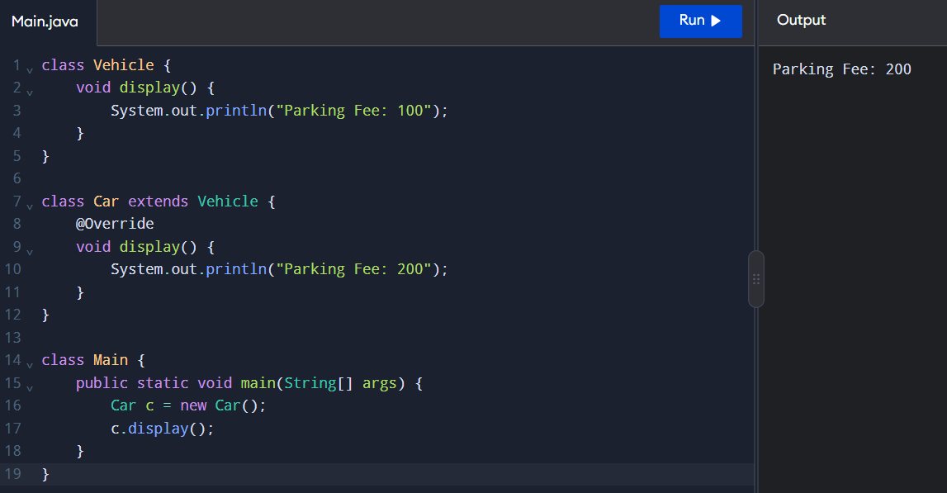

2. Expected Output
TwoWheeler
Fee: 20.0
Car
Fee: 50.0
3. Explanation
- Method overriding: A child class provides its own implementation of a method inherited from its parent class.
- @Override: Indicates that a method is intended to override a parent-class method.
- Runtime polymorphism: The method executed depends on the actual object type at runtime.
- toString(): Returns a readable string representation of an object.
- equals(): Compares objects for logical equality when appropriately overridden.
- hashCode(): Returns a hash value and should be consistent with equals().
4. Use of the final Keyword
The final keyword prevents a method from being overridden by a subclass.
Example:
final void displayParkingRules() {
System.out.println("Follow Parking Rules");
}
A subclass cannot override displayParkingRules().
5. Method Overriding vs Switch Statement
Method Overriding | Switch Statement
Uses inheritance. | Uses conditional selection.
Supports runtime polymorphism. | Selects a case based on a value.
Each vehicle class defines its fee. | Fee logic is grouped in one method.
Easier to extend with new vehicle types. | New types may require modifying the switch.
Supports object-oriented design. | Suitable for simple fixed conditions.
Result
Method overriding was implemented successfully for TwoWheeler and Car. The @Override annotation and toString() method demonstrated runtime polymorphism and object representation in Java.

TASK 8 – Polymorphism and Method Overloading
Aim
To understand compile-time polymorphism through method overloading and runtime polymorphism through method overriding in the Campus Smart-Parking System.

1. Method Overloading
Method overloading means defining multiple methods with the same name but different parameter lists.
Example:
double calculateFee(int hours) {
return hours * 50;
}
double calculateFee(int hours, double rate) {
return hours * rate;
}

2. Complete Java Program – FeeDemo.java
class Vehicle {
double calculateFee(int hours) {
return hours * 50;
}
double calculateFee(int hours, double rate) {
return hours * rate;
}
}
class Car extends Vehicle {
@Override
double calculateFee(int hours) {
return hours * 60;
}
}
public class FeeDemo {
public static void main(String[] args) {
Vehicle v = new Vehicle();
System.out.println("Fee: " + v.calculateFee(2));
System.out.println("Fee: " + v.calculateFee(3, 40));
Vehicle c = new Car();
System.out.println("Car Fee: " + c.calculateFee(2));
}
}
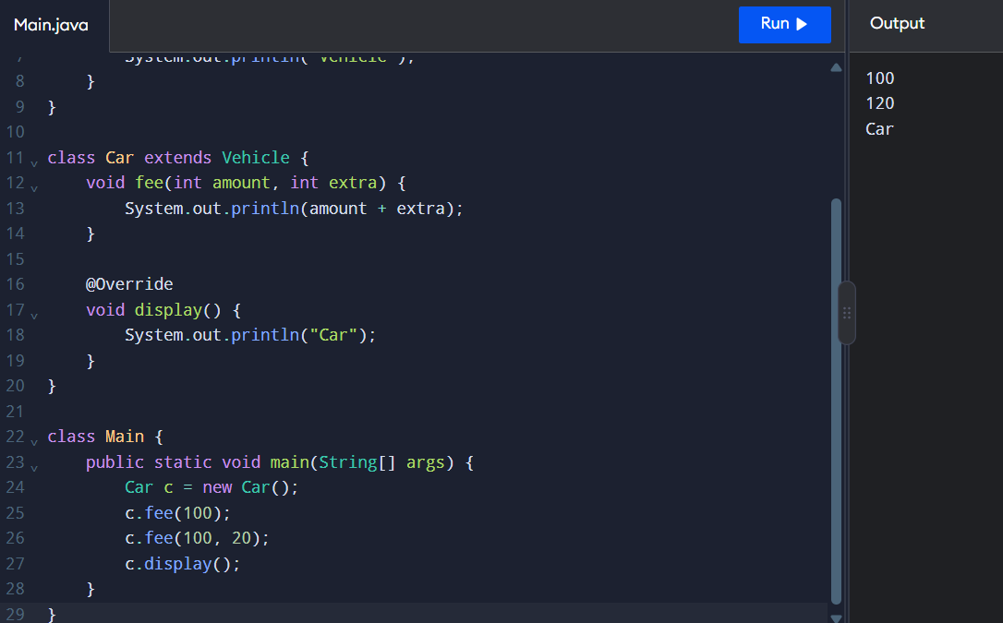

3. Expected Output
Fee: 100.0
Fee: 120.0
Car Fee: 120.0

4. Explanation
- Method overloading: Methods have the same name but different parameters.
- Compile-time polymorphism: The compiler selects the overloaded method based on the arguments.
- Method overriding: A child class provides its own implementation of a parent-class method.
- Runtime polymorphism: The overridden method is selected according to the actual object type.
- Dynamic method dispatch: Vehicle c = new Car(); calls the Car implementation of calculateFee(2).

5. Overloading vs Overriding
Method Overloading | Method Overriding
Same method name with different parameters. | Same method signature in parent and child classes.
Usually occurs within the same class. | Requires inheritance.
Compile-time polymorphism. | Runtime polymorphism.
Return type alone cannot distinguish overloaded methods. | Return type must be compatible with the parent method.
Example: calculateFee(2, 40). | Example: Car overrides calculateFee(2).

Result
Method overloading and method overriding were implemented successfully. The program demonstrates compile-time polymorphism, runtime polymorphism, and dynamic method dispatch in Java.

TASK 9 – Abstract Classes and Interfaces
Aim
To understand abstract classes and interfaces in Java and implement them in the Campus Smart-Parking System.

1. Abstract Class
An abstract class is declared using the abstract keyword. It can contain both abstract methods and normal methods. An abstract class cannot be instantiated directly.

2. Java Program
abstract class Vehicle {
String vehicleNo;
Vehicle(String vehicleNo) {
this.vehicleNo = vehicleNo;
}
abstract double calculateFee();
void display() {
System.out.println("Vehicle No: " + vehicleNo);
}
}
interface Chargeable {
void charge();
}
class ElectricCar extends Vehicle implements Chargeable {
ElectricCar(String vehicleNo) {
super(vehicleNo);
}
@Override
double calculateFee() {
return 60;
}
@Override
public void charge() {
System.out.println("Electric Car Charging");
}
}
public class Main {
public static void main(String[] args) {
ElectricCar e = new ElectricCar("TN01AB1234");
e.display();
System.out.println("Parking Fee: " + e.calculateFee());
e.charge();
}
}
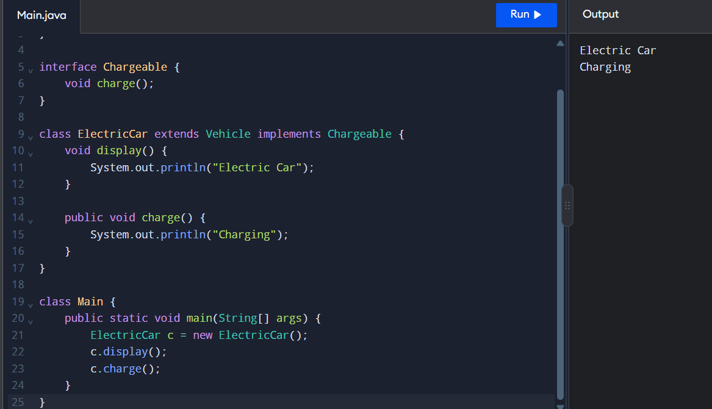

3. Expected Output
Vehicle No: TN01AB1234
Parking Fee: 60.0
Electric Car Charging

4. Explanation
- Abstract class: Provides common properties and methods for related classes.
- Abstract method: A method declared without a method body.
- Interface: Defines a contract that implementing classes must follow.
- extends: Used by a class to inherit an abstract class.
- implements: Used by a class to implement an interface.
- super(): Calls the parent-class constructor.
- @Override: Indicates that a method implements or overrides an inherited method.

5. Abstract Class vs Interface
Abstract Class | Interface
Declared using abstract class. | Declared using interface.
Can have instance variables. | Fields are implicitly public static final.
Can have constructors. | Cannot have constructors.
A class can extend only one class. | A class can implement multiple interfaces.
Example: Vehicle. | Example: Chargeable.

Result
An abstract class and an interface were implemented successfully. The program demonstrates abstraction, inheritance, method overriding, and interface implementation in Java.

TASK 10 – Packages, Access Modifiers and Encapsulation
Aim
To understand packages, access modifiers, getters, setters, and autoboxing in Java using the Campus Smart-Parking System.

1. Packages in Java
A package is a collection of related classes and interfaces. It helps organize code and avoid naming conflicts.
Example:
package parking;
Save the file as Vehicle.java inside the parking package folder.

2. Java Program – Vehicle.java
package parking;
public class Vehicle {
private String vehicleNo;
private String vehicleType;
public Vehicle(String vehicleNo, String vehicleType) {
this.vehicleNo = vehicleNo;
this.vehicleType = vehicleType;
}
public String getVehicleNo() {
return vehicleNo;
}
public void setVehicleNo(String vehicleNo) {
this.vehicleNo = vehicleNo;
}
public String getVehicleType() {
return vehicleType;
}
public void setVehicleType(String vehicleType) {
this.vehicleType = vehicleType;
}
public void display() {
System.out.println("Vehicle No: " + vehicleNo);
System.out.println("Vehicle Type: " + vehicleType);
}
}

3. Java Program – Main.java
import parking.Vehicle;
public class Main {
public static void main(String[] args) {
Vehicle v = new Vehicle("TN01AB1234", "Car");
v.display();
v.setVehicleType("Electric Car");
System.out.println("Updated Type: " + v.getVehicleType());
// Autoboxing
int count = 5;
Integer total = count;

System.out.println("Total Vehicles: " + total);
}
}
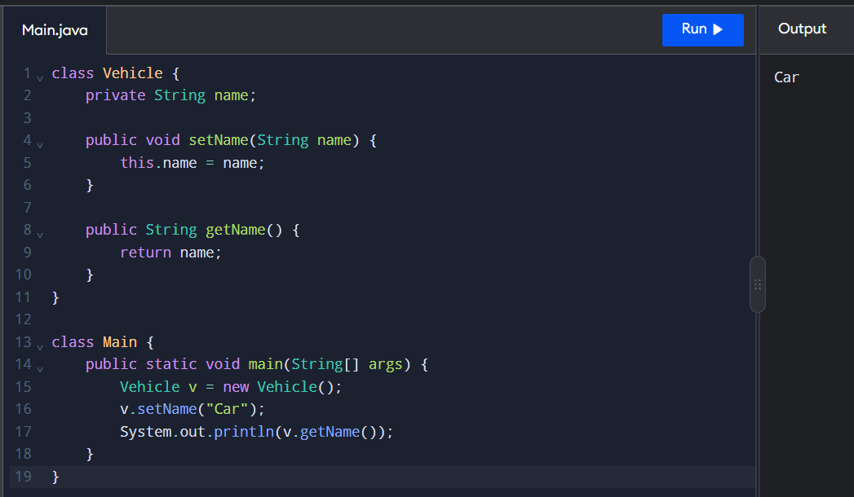

4. Expected Output
Vehicle No: TN01AB1234
Vehicle Type: Car
Updated Type: Electric Car
Total Vehicles: 5

5. Explanation
- Package: Organizes related classes. Example: parking.
- private: Allows access only within the same class.
- public: Allows access from other classes.
- protected: Allows access within the same package and through inheritance, subject to Java access rules.
- Default access: When no access modifier is specified, access is limited to the same package.
- Getter: Returns the value of a private variable.
- Setter: Updates the value of a private variable.
- Autoboxing: Automatically converts a primitive value into its corresponding wrapper object, such as int to Integer.

6.Access Modifiers Comparison
Modifier | Access
private | Same class only
Default | Same package
protected | Same package and eligible subclasses
public | Accessible from anywhere, subject to other restrictions

7. Encapsulation vs Public Fields
Encapsulation | Public Fields
Uses private variables. | Uses public variables.
Accesses data through getters and setters. | Accesses data directly.
Provides better control over data. | Provides less control over data.
Improves maintainability. | May make changes harder to manage.

Result
Packages, access modifiers, getters, setters, and autoboxing were demonstrated successfully in Java. Encapsulation protects vehicle details and allows controlled access to object data.

TASK 11 – Implementation, Testing and Validation
Aim
To implement and test the Campus Smart-Parking System using Java and validate its parking allocation, release, and fee calculation operations.

1. Implementation
The system uses the following classes and components:
- Vehicle – stores vehicle details.
- ParkingSlot – represents an individual parking slot.
- ParkingFloor – manages slots on a floor.
- ParkingFacility – allocates and releases parking slots.
- ParkingFeeCalculator – calculates parking charges.

2. Test Cases
Test Case | Input / Condition | Expected Output
TC01 | Allocate a vehicle when a slot is free | Slot allocated successfully
TC02 | Allocate vehicles until all slots are occupied | All available slots allocated
TC03 | Allocate a vehicle when parking is full | null or parking-full message
TC04 | Release an occupied slot | true
TC05 | Release an already-free slot | false
TC06 | Release an invalid floor | false
TC07 | Release an invalid slot number | false
TC08 | Calculate fee for 2 hours at ₹50 per hour | ₹100
TC09 | Calculate fee for zero minutes | ₹0
TC10 | Allocate a vehicle after releasing a slot | Released slot can be reused

3. Sample Java Testing Code
public class ParkingTest {
public static void main(String[] args) {
ParkingFacility p = new ParkingFacility(new int[]{2, 1});
System.out.println(p.allocate("TN01AB1111") != null);
System.out.println(p.allocate("TN02CD2222") != null);
System.out.println(p.allocate("TN03EF3333") != null);
System.out.println(p.allocate("TN04GH4444") == null);
System.out.println(p.release(0, 1));
System.out.println(p.release(0, 1));
System.out.println(p.allocate("TN04GH4444") != null);
}
}
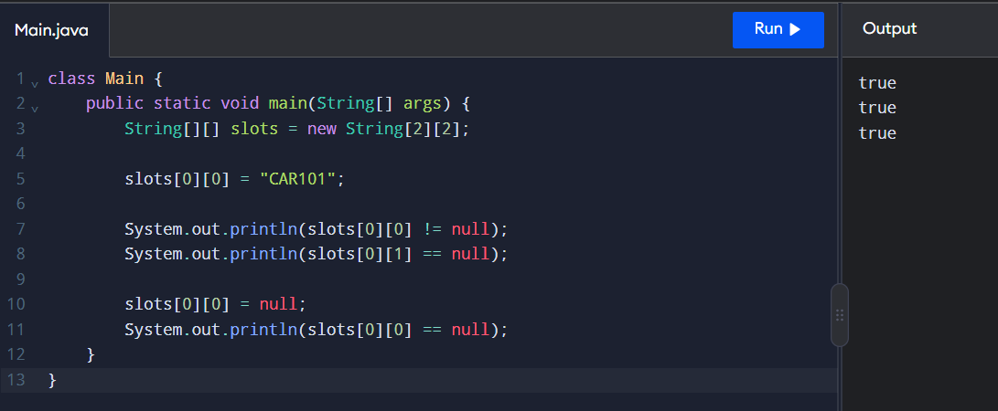
Expected Output
true
true
true
true
true
false
true

4. Daily Parking Fee Collection
The system can calculate daily revenue by adding the parking fees collected from all vehicles.
double totalCollection = 0;
double fee1 = 100;
double fee2 = 150;
double fee3 = 50;
totalCollection = fee1 + fee2 + fee3;
System.out.println("Daily Collection: Rs. " + totalCollection);
Output
Daily Collection: Rs. 300.0

5. Array vs ArrayList vs HashMap
Feature | Array | ArrayList | HashMap
Storage | Fixed size | Dynamic size | Key-value pairs
Access | Using index | Using index | Using key
Size | Cannot grow automatically | Can grow or shrink | Can grow or shrink
Best use | Fixed parking slots | Dynamic vehicle list | Vehicle number lookup
Example | String[] slots | ArrayList<String> | HashMap<String, Vehicle>

Result
The Campus Smart-Parking System was implemented and tested using Java. The test cases validated slot allocation, full-parking handling, slot release, invalid inputs, and reuse of released slots. Daily parking revenue was calculated, and arrays, ArrayList, and HashMap were compared for suitable data storage.

TASK 12 – Design Challenge: Extending the Smart-Parking System
Aim
To enhance the Campus Smart-Parking System by introducing new vehicle categories, special parking charges, visitor passes, and support for multiple floors with unequal slot capacities.

1. Proposed Enhancements
- E-bike parking: Charge a fixed flat fee for electric bikes instead of calculating the fee by the hour.
- Delivery van parking: Charge delivery vans twice the normal car parking rate between 9:00 AM and 5:00 PM.
- Visitor pass: Provide visitors with a one-day parking pass that is valid for one day.
- Five-floor parking: Extend the system to support five floors, each having a different number of parking slots.

2. Impact Analysis
Enhancement | Required Change | Expected Benefit
E-bike flat fee | Add a separate fee calculation rule | Simple and consistent charging
Delivery van rate | Check vehicle type and entry time | Supports time-based pricing
Visitor pass | Store pass validity and expiry date | Controls visitor parking
Five floors | Use a variable-size array for each floor | Supports unequal slot capacities

3. Modified Java Code
class ParkingFeeCalculator {
static double calculateFee(String type, int hours, int entryHour,
double carRate, double eBikeFlatFee) {
if (type.equalsIgnoreCase("E-Bike")) {
return eBikeFlatFee;
}
if (type.equalsIgnoreCase("Delivery Van")
&& entryHour >= 9 && entryHour < 17) {
return hours * carRate * 2;
}
return hours * carRate;
}
}
class VisitorPass {
String visitorName;
String expiryDate;
VisitorPass(String visitorName, String expiryDate) {
this.visitorName = visitorName;
this.expiryDate = expiryDate;
}

void display() {
System.out.println("Visitor: " + visitorName);
System.out.println("Valid Until: " + expiryDate);
}
}
public class Main {
public static void main(String[] args) {
double bikeFee = ParkingFeeCalculator.calculateFee(
"E-Bike", 3, 10, 50, 20);
double vanFee = ParkingFeeCalculator.calculateFee(
"Delivery Van", 2, 10, 50, 20);
System.out.println("E-Bike Fee: Rs. " + bikeFee);
System.out.println("Delivery Van Fee: Rs. " + vanFee);
VisitorPass pass = new VisitorPass("Arun", "17-10-2026");
pass.display();
int[] slotsPerFloor = {20, 25, 15, 30, 18};
String[][] parking = new String[5][];
for (int i = 0; i < 5; i++) {
parking[i] = new String[slotsPerFloor[i]];
}
System.out.println("Total Floors: " + parking.length);
}
}
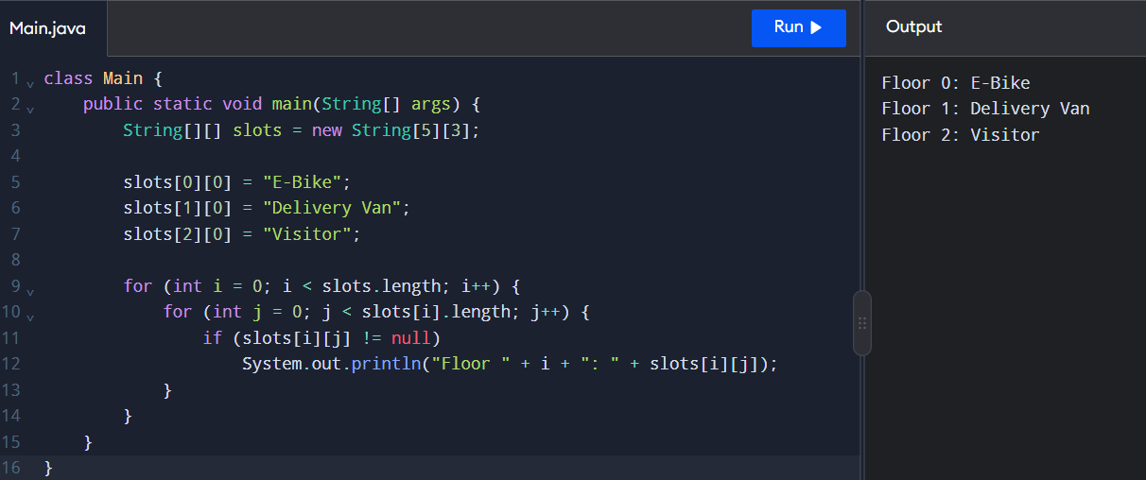

4. Expected Output
E-Bike Fee: Rs. 20.0
Delivery Van Fee: Rs. 200.0
Visitor: Arun
Valid Until: 17-10-2026
Total Floors: 5
Note: The example uses an e-bike flat fee of ₹20 and a car rate of ₹50 per hour. These are illustrative values, not specified rates from the assignment. The visitor pass example stores an expiry date; actual date validation must be added to enforce one-day validity.

5. Evaluation of the Proposed Design
- Maintainability: Separate fee calculation and visitor-pass classes make the system easier to update.
- Scalability: A jagged array supports five floors with different slot capacities.
- Flexibility: New vehicle categories can be added with separate pricing rules.
- Reliability: Visitor-pass expiry and parking-slot availability should be validated before granting access.
- Performance: Slot allocation using a sequential search takes \(O(N)\) time in the worst case, where \(N\) is the total number of slots.

6. Alternative Approach
Instead of storing parking slots in a jagged array, the system can use an ArrayList for each floor. This allows parking capacity to change dynamically. A HashMap can also be used to find vehicles quickly using their registration numbers.

Result
The Smart-Parking System was extended conceptually to support e-bike flat fees, time-based delivery van charges, visitor passes, and five floors with unequal parking capacities. The proposed design improves flexibility, scalability, and maintainability.

